**MS Power BI**

Data Set: [TB burden by country](https://public.tableau.com/app/sample-data/TB_Burden_Country.csv?_gl=1*fcnmh8*_ga*MTI1OTE0NDMzLjE3NDAyNjExNDQ.*_ga_8YLN0SNXVS*MTc0MDM4MjMzNy4zLjAuMTc0MDM4MjMzNy4wLjAuMA..)

Visual Reports:

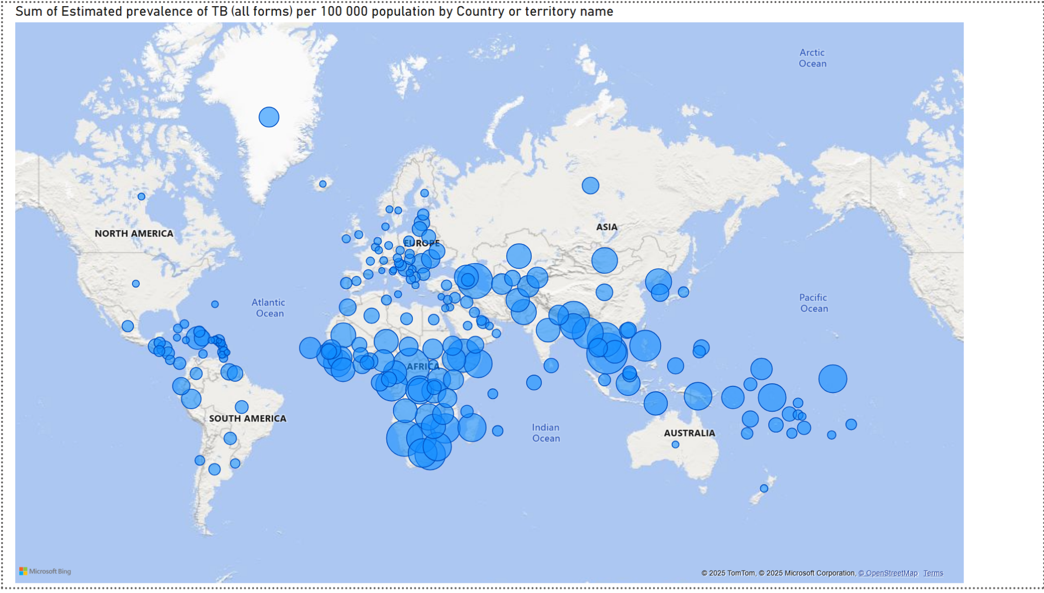

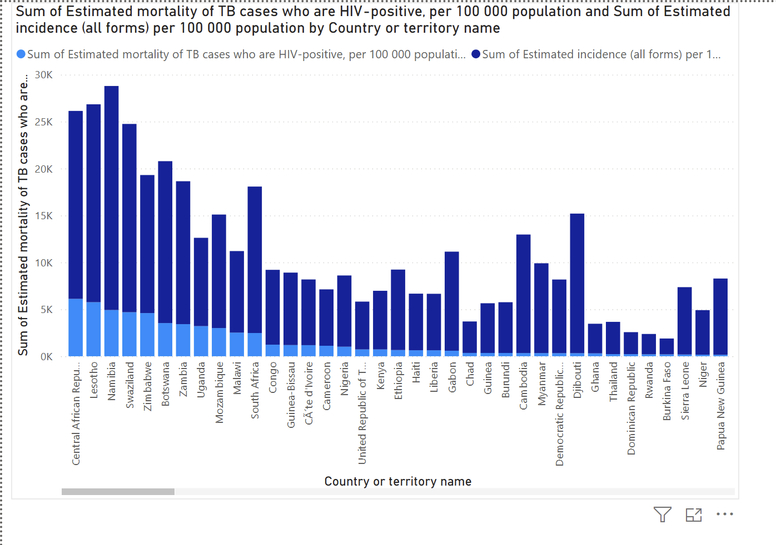

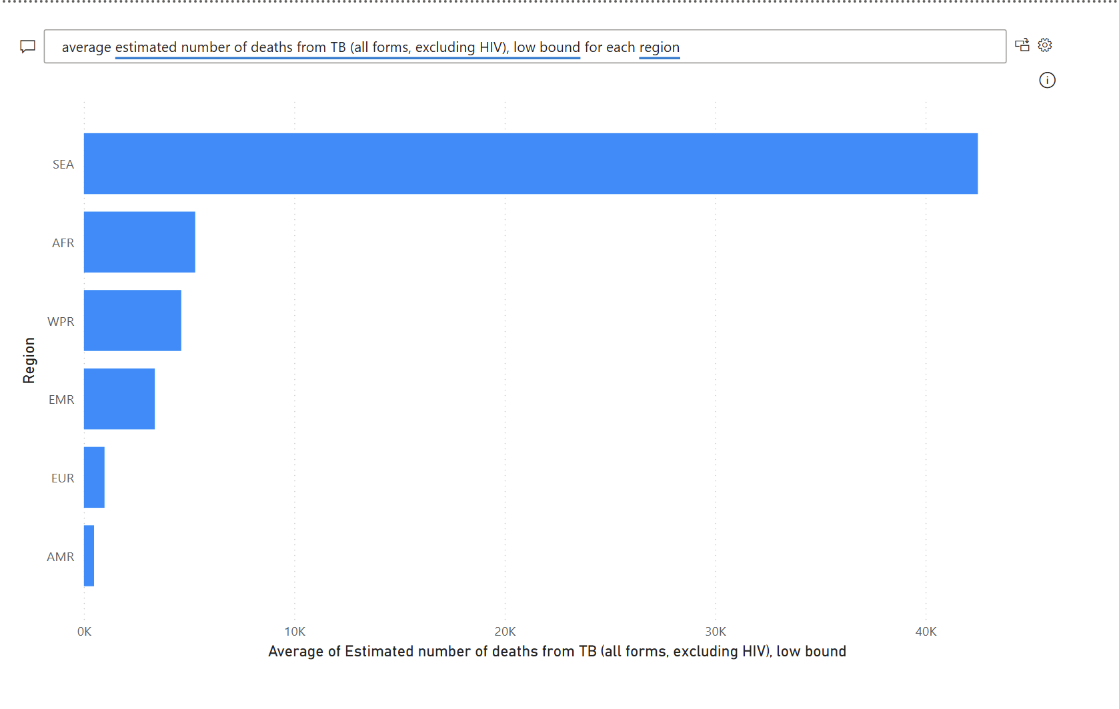

Score and Certificate:

